|  |  |  |  |  |  |  |
| --- | --- | --- | --- | --- | --- | --- |
| **Practicum Final Exam – Odd Semester Year 2021/2022** | | | | | | |
| **Subject** | | | **COMP6153001 – Operating System** | | |  |
| **Class** | **:** | **BC80** | | **Start Date** | **: 14 January 2022** |
| **Lecturer** | **:** | **D5151 - Ikhtiar Faahakhododo, S.Kom., M.TI** | | **Start Time** | **: 11:20 WIB** |
| **End Date** | **: 14 January 2022** |
| **End Time** | **: 13:20 WIB** |

**PERATURAN UJIAN:**

*Exam Regulations:*

* Mahasiswa tidak diperbolehkan berdiskusi dan/atau bekerja sama dengan peserta ujian lainnya

*Student is not allowed to discuss and/or work together with other exam participants*

* Mahasiswa tidak diperbolehkan untuk membuka dan menyalin dari **BUKU** atau **CATATAN**, **VIDEO** dari pengajar (recording kelas, VBL, Youtube, dsb) dan **REFERENSI** lainnya

*Student isn't allowed to open and copy from any resources such as notes, videos (class recording, VBL, Youtube, etc) and other references*

* Mahasiswa tidak diperbolehkan membuka dan menyalin jawaban dari internet (google, stackoverflow, dsb)

*Student isn't allowed to open and copy answer from the internet (google, stackoverflow, etc)*

* Asisten **BERHAK** memberi nilai 0 **(NOL)** bagi peserta ujian yang melakukan segala bentuk kecurangan

*Assistant is able to give 0 (ZERO) score for exam participant who does any cheating actions*

* Kumpulkan jawaban tepat pada waktunya, apabila terlambat mengumpulkan maka jawaban tidak akan dikoreksi dan nilai mahasiswa adalah 0

*Submit the answer on time, if not, then the answer will not be checked, and the students will receive 0 (ZERO)*

* Bila Anda tidak membaca peraturan ini, maka Anda dianggap telah membaca dan menyetujuinya

*If you have missed to read these regulations, so you are considered to have read and agreed on it*

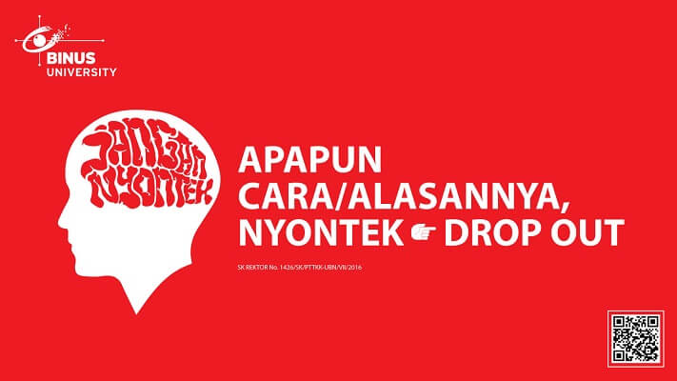

**SOFTWARE YANG DIGUNAKAN:**

*Software will be used:*

* Java 8
* Eclipse 2020.6
* NachOS 5.0j

**FILE YANG DIKUMPULKAN:**

*File must be collected:*

* JAVA
* CLASS

**PERHATIAN!**

*Attention!*

* Bagi yang mengerjakan tidak sesuai dengan soal, maka akan diberikan nilai **NOL (0)**

*For those who do not work in accordance with the exam case will be marked as* ***ZERO (0)***

* Bagi yang mengerjakan tidak sesuai dengan software dan versi yang telah ditetapkan, maka akan tetap dikoreksi dengan software dan versi yang telah ditetapkan

*For those who do not work in accordance with the software and specific version will be corrected by the predefined software and version*

* Kompres semua jawaban yang akan diunggah. Pastikan format pengumpulan nama file dan ekstensi sesuai dengan format berikut: **[NIM]-[NAMA].zip**

*Compress all file that will be uploaded. Make sure the format for collecting file name and extension according to the following format:* ***[NIM]-[NAME].zip***

**Important Notes**:

1. Use your **own Console** and **Scheduler (FIFO)**.
2. Youmustuse **Semaphore** to **control** operation.
3. You must use **Timer** to generate tick of time.
4. You must use **Network Link** to send the data.
5. Use **KThread**.

**Soal**

*Case*

**Registration Form**

**Meet Bot** is a company engaged in technology and education. Currently **Meet Bot** is developing an application called **Registration Form** to facilitate the university in conduction transferring student to another university. You, as a programmer were tasked to create the program. As they are still new in this industry, their first goal is to create a dependable transfer system using **nachOS**’ **network link** in **Java programming language**.

First, this application will show the **University ID** (based on the network link address) and **3 main** **menus** consist of:

* + **Transfer Student**
  + **Receive Student(s)**
  + **Exit**

**Figure 1. Menu**

1. **Transfer Student (Menu 1)**

The first menu allows user to **insert a Student Detail**. The inserting process follow the following steps:

* + - * First, the program will ask user to input the **name**. Validate the **name length** must be **between 5 and** **30 characters**.
      * After that, the program will ask user to input the **major**. Validate the **major** must be **either** “**Computer Science**” **or** “**Information System**” (**case sensitive**).
      * Every **major** has its own **price** according to this table:

|  |  |
| --- | --- |
| **Major** | **Price** |
| Computer Science | 200000 |
| Information System | 150000 |

* + - * After that, the program will ask user to input the **quantity**. Validate the **quantity** must be **numeric** and **between 1 and** **10**.
      * Every **quantity** will get a **discount** according to this table:

|  |  |
| --- | --- |
| **Quantity** | **Discount** |
| more than or equals to 5 | 20% |
| more than or equals to 3 | 10% |

* + - * Then, the program will **calculate** the **total price** based on **price**, **quantity**, and **discount** with the following formula:



* + - * Ask the user to input the receiver’s **University ID**.
      * After fulfilling all validations, the application will **send** the student and **show a message**.

**Figure 2. Insert All Data**

* + - * Save the **student data** in a **Collection** (**Vector / ArrayList / Array**).

1. **Receive Student(s) (Menu 2)**

The second menu allows university to **view all received student inside the list**. The receiving process follow the following steps:

* + - * If there’s **no received student**, then **display message** “**There is No Transferred Student to You. Check Again Another Time!**”.

**Figure 3. No Received Student Error Message**

* + - * Otherwise, if the current university **has available student(s)**, the application will **show all student received** using **KThread** and **Scheduler** (**FIFO concept**). The student **will be shown with delay 1000 milliseconds** (use **Thread sleep**).

**Figure 4. View Existing Students Received**

1. **Exit (Menu 3)**

When user choose this menu, the program **will print tick of time using Timer** and .After that, the application will **exit**.

**Figure 5. Exit Message**

**Must be collected:**

1. Java Project (Including NachOS and student’s code) compressed (.zip)